CS506

**Final Report**

City Budget Group E

December, 2023

Wanchen Hong, Zhupei Xu, Alex Zhang and Phil Ledoit, Class of 2024

Email: {wghong, xuzhupei, zhangal, pledoit}@bu.edu

# 

# Introduction

Budgeting is an essential part of a functioning city. As one of the largest cities in the US, it is crucial to reflect on Boston’s government spending to ensure a healthy balance. The goal is to visualize and evaluate budget change over time, projected vs actual spending, and per capita spending in the following categories: department, budget category, geography and program.

## Datasets

For the base project, the datasets were downloaded from the government website at Analyze Boston. We used both the [Opearting Budget dataset](https://data.boston.gov/dataset/operating-budget/resource/8f2971f0-7a0d-401d-8376-0289e3b810ba) and the [Capital Budget dataset](https://data.boston.gov/dataset/capital-budget/resource/c62d666e-27ea-4c03-9cb1-d3a81a1fb641) for the base questions. To begin with, the basic information of the dataset is checked, as well as the number of unique values and missing values, to determine what needs to be done. The result shows that there is no missing data, and a lot of unique data. Noticeably, columns that should be numerical (such as Total_Project_Budget) have attribute objects, indicating that it is imported as a string instead. This value issue is resolved in the cleaning process. The column names are also renamed to eliminate inconsistencies and ensure they are meaningful.

For the extension project, the datasets used are from [Analyze Boston](https://data.boston.gov/dataset/checkbook-explorer). The CSV files were imported with encoding through pandas to avoid any issues, and the datasets were checked for NA values. The NA values are filled with the appropriate month value according to their enter data in the dataset, and the column names were changed to maintain consistency. The dataset was then combined together as the entire spending history of the city of Boston in the last decade.

## Exploratory Data Analysis

One of the most significant findings from the exploratory data analysis is that the budget from Fiscal Year (FY) 21 to FY24 is increasing, almost linearly (Fig 1, b). This is a very significant result as we are interested in how it is changing over time. However, since there were other events concurrently (eg. COVID), it is unknown to us whether this increasing trend has been consistent, or is it simply because of the monetary policy in 2021.

The departments with the most projects are park and recreation and Boston public schools (Fig 1, a). Not surprisingly, they also have the most project budgets across all departments. Noticeably, Boston Public schools receive the most funding out of all departments, followed closely by Public Works, which potentially indicates that the city of Boston is distributing its budget more towards social benefits of the people (Fig 1, c).

One other interesting observation is that most projects, excluding annual programs, have status indicating that they will be completed in the future, which implies more social spending has been made in the recent years from the Boston Budget (Fig 1, d).

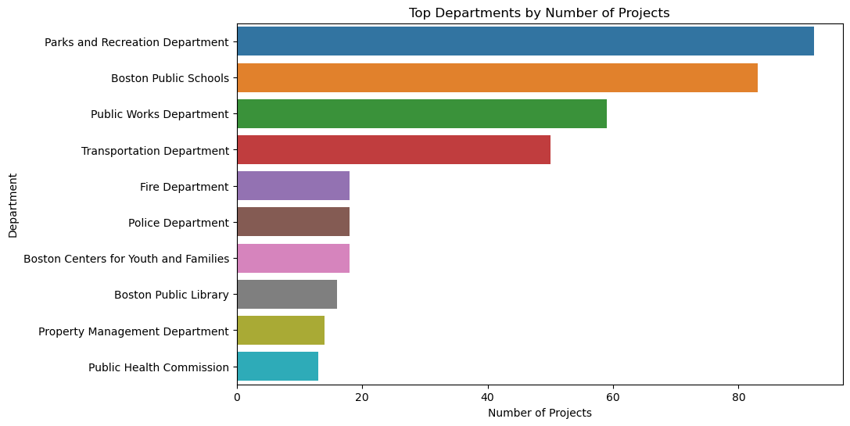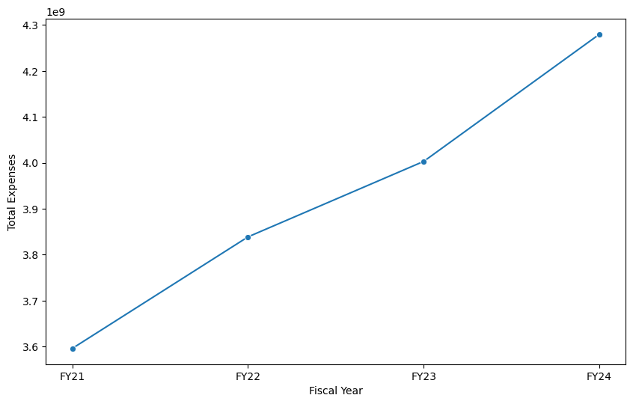

(a) (b)

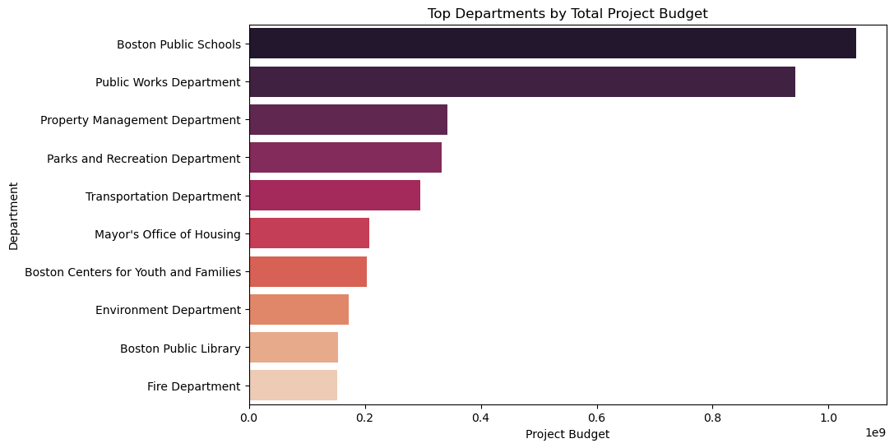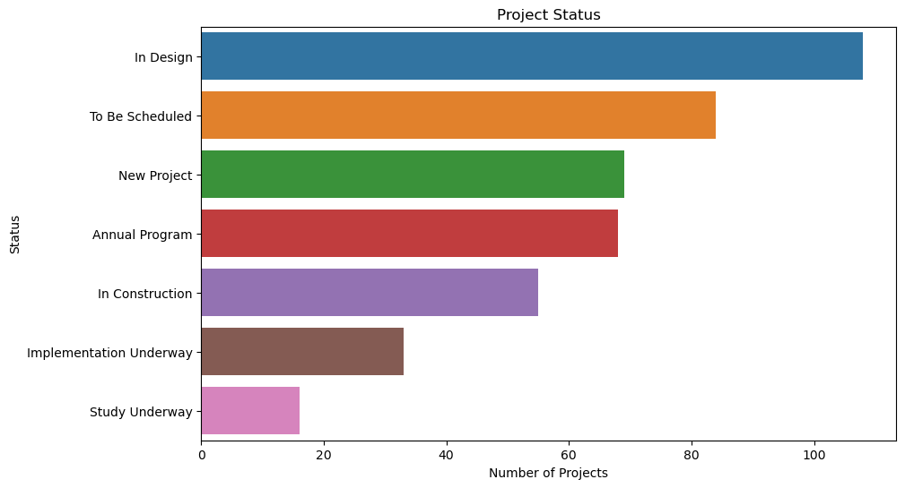

(c) (d)

Figure 1. Exploratory Analysis Results. a) histogram of the departments with the most projects; b) plot of total expenses vs. time; c) histogram of the departments with the most project budges; d) histogram of the distribution of project statuses.

# 

# Base Analysis

For the base analysis, we attempt to analyze how Boston’s city budget change in department, category, area and program. We will analyze and visualize the results of each component separately.

## Spending by department

Most apartments show a increasing trend in spending as expected since the overall budget are increasing. The "Boston Public Schools" department which has the highest spending among all the departments shows clear upward trend in spending from FY21 through FY24, reflecting a strong focus on education (Fig 2).

The consistent increase in the Health Insurance budget might be in response to rising healthcare costs or an increase in city employee benefits. This could be a response to public health challenges, possibly influenced by the COVID-19 pandemic.

When comparing the actual spending (2021-2023) and projected spending (2024-2028), we observe some significant differences including the disappearance of some departments and the appearance of new ones. It is possible that the data is incomplete. But assuming the data is correct, this difference may be due to department reorganization by the government.

The results (Fig 2) indicate a significant and consistent increase in per-student spending over the years. This trend suggests that Boston is investing more resources per student each year in its public school system.

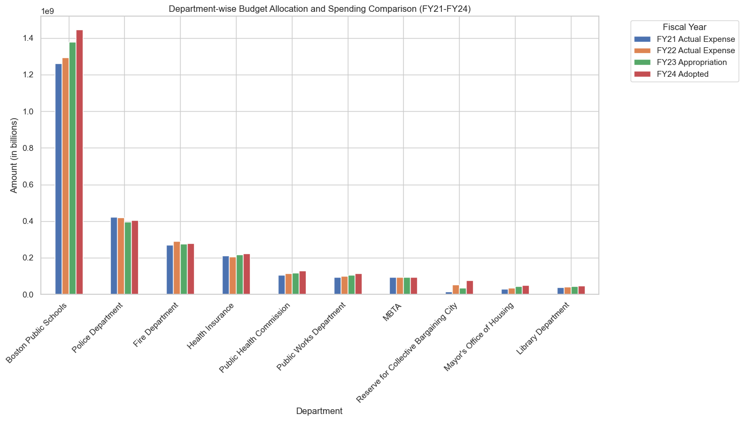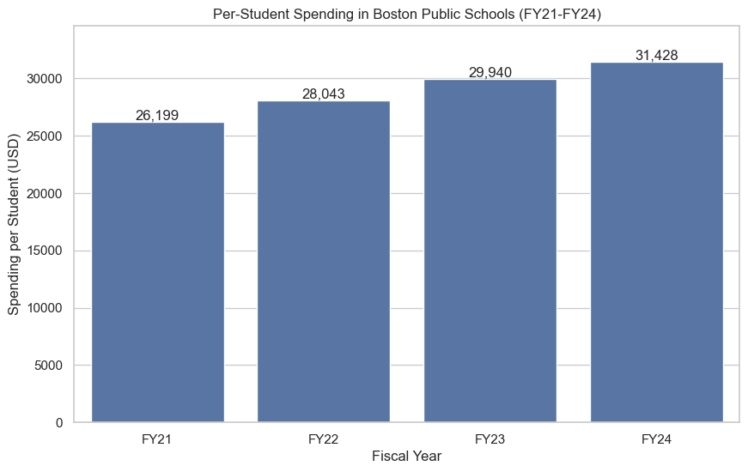

(a) (b)

Figure 2. Visualization results of spending by department. a) histogram of top spending departments across the four years; b) histogram of per student spending in Boston Public Schools each year across the four years.

## 

## Spending by category

As one might expect, spending by budget category is also trending upwards. Personnel expenses are a significant portion of the budget, which is quite reasonable given that manpower is generally extremely expensive (Fig 3).

Contractual services dipping for ‘23 is a bit strange, but seems to be resuming its upwards trend in ‘24. Otherwise, not much seems to be out of the ordinary. Spending is relatively in line with projections, with steady growth. Other expenses does make up a large chunk of the city budget, however, and in further analysis we could potentially break down “Other expenses” into more specific categories to better evaluate the spending.

Furthermore, an expanded dataset would help us to better evaluate past and future budgetary trends, as the data we have available is somewhat limited.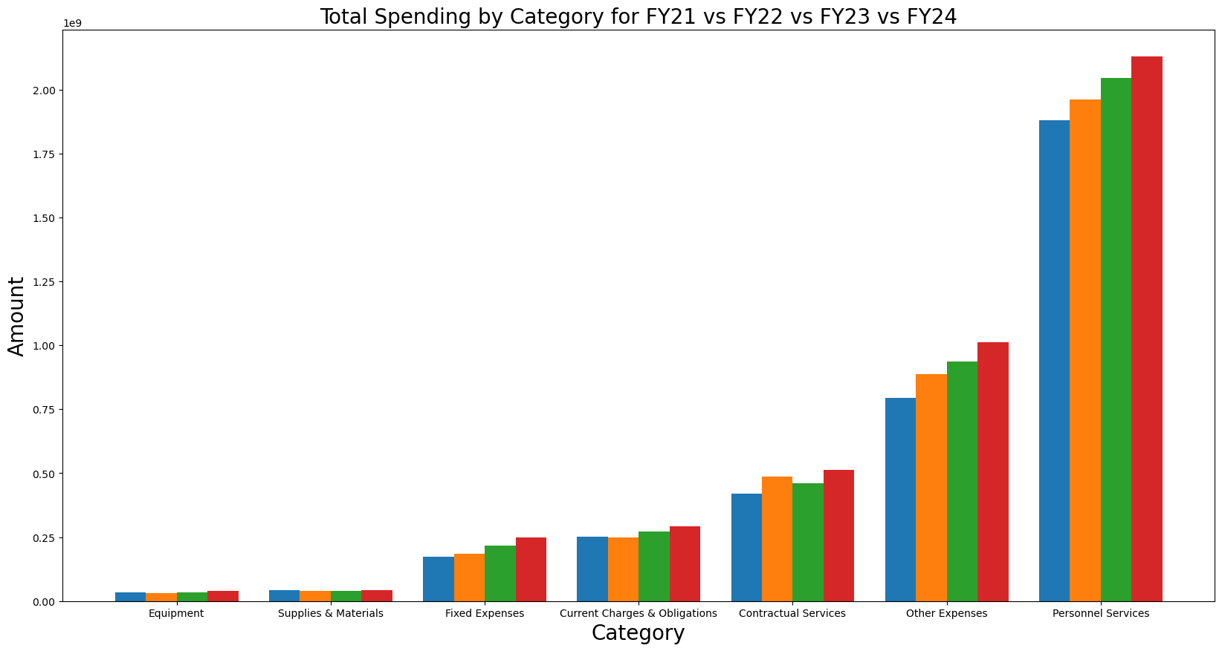

Figure 3. Top Spending Categories for each year.

## 

## 

## 

## 

## Spending by area

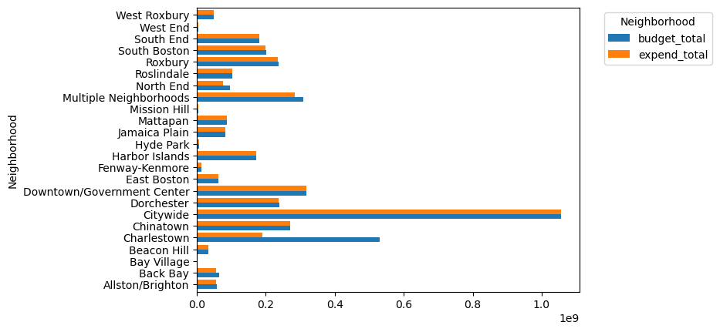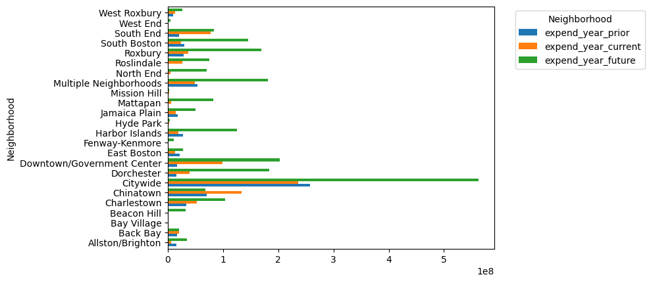

(a) (b)

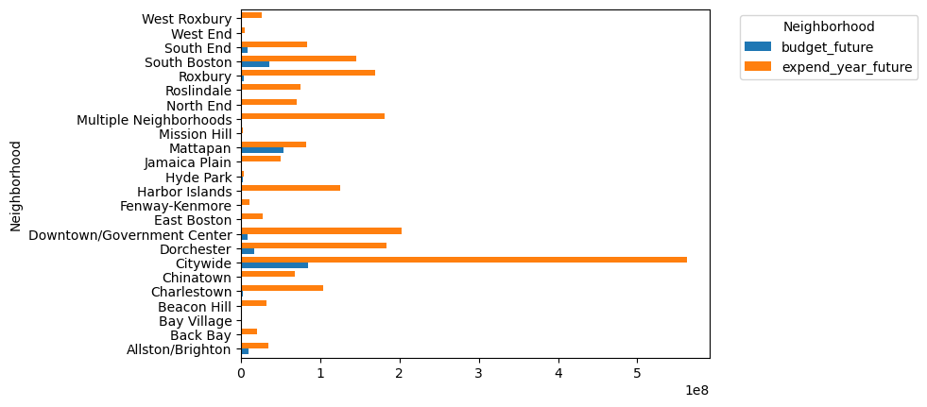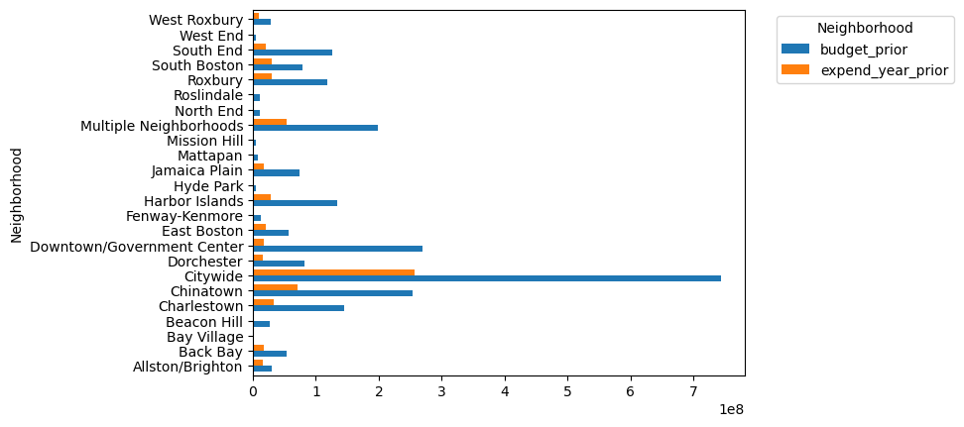

(c) (d)

Figure 4. Histograms of budget vs. expenditures. a) total budget vs. expenditures; b) prior, current and future expenditures; c) future budget vs. future expenditures; d) prior budget vs prior expenditures.

In examining the budget across different areas, the result shows that future funding makes up the majority of the budget (Fig 4). Notieceably, Dorchester and Roslindale are some individual areas with the highest projected expenditure, understanding the underlying reasons could offer some insights to the city project.

Compare between budget and expenditure, it shows that the total amount of projected spending (budget) is at least the total amount of the expenditure. However, they are distributed differently. The budget are mostly set in the prior years for all areas, while the spending would occur in the future years instead.

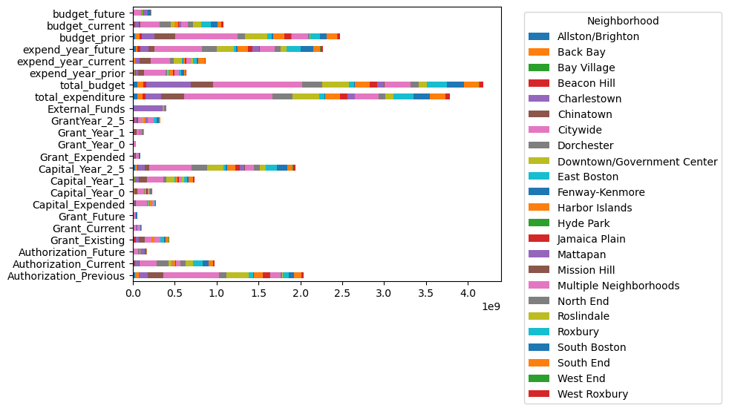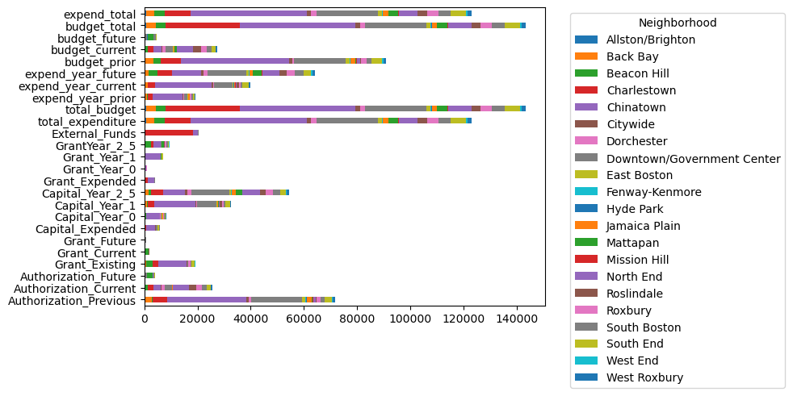

(a) (b)

Figure 5. Stacked Histograms of different budget categories by neighborhood. a) total budget; b) budget per capita.

From the total budget per area (Fig 5, a), city wide projects are granted the most, followed by budget in Charlestown, multiple neighborhoods and Chinatown. However, for the budget per capita per area (Fig 5, b), it is Chinatown that has the highest number, followed by Charlestown and downtown. Interestingly, for Charlestown, external funds make up a majority of the budget, which it would be interesting to see which project (s) this came from.

## Spending by program

Figure 6. Pie chart of average spending by Program. Pensions has the most spending, which is reasonable.

# 

Analysis incomplete from team member.

# Extension Analysis

Overall, we see that the budget of the city of Boston has been increasing from 2021 to 2024, across most of the categories. Meanwhile, the expenditure over the times never exceeded the overall budget, indicating that the budgeting in Boston is robust.

Since the data only covers 4 years, it places a limitation of a grand overview of the budget of Boston. We expect to explore more cross the categories for any more potential interesting findings, and to complete a robust examination of the budgeting of Boston. One particular interest we have is to explore more about how the budgeting before 2021, to see how it behaves over time, and to see if our observations from the current years still apply, or it is related more to current events (eg. COVID).

We would like to analyze the past data to find more patterns with regard to the budgeting and spending in time, as well as how the budget changes over a longer period of time. We believe that the general increasing trend would still apply. We will be using the checkbook dataset from [Analyze Boston](https://data.boston.gov/dataset/checkbook-explorer), which includes past budget since 2012. We will examine the budget vs. time, possibly across different departments.

In addition, we would like to look at how the city government is funded, and how this might have changed over time, using historical revenue data and evaluating potentially correlated data.

## Analysis Result

The dataset for the extension project contains the spending data from the first fiscal month of 2012 to the fifth fiscal month of 2023, which is incomplete for 2023.

First, the dataset is plotted as a time series data. The fiscal year of 2023 is incomplete, which means the spending for 2023 might not provide much insights overall. The result shows possible seasonal trends by month (Fig 7, a), with a general increasing trend over the entire period of time, and a generally higher budget for winter months. The yearly plot (Fig 7, b) shows this increasing trend more clearly. However, compared to the recent spendings from FY 2021 to 2024 (Fig 7, c), it shows that the trend of spending has really increased drastically since 2019. Before that, the slope of increasing is much more flat. This potentially suggests that the increasing spending is very likely boosted by the monetary policy since COVID, and perhaps after a few years, this spending would go back to the relatively flat level pre COVID.

Over the past decade, the total expenses across the different departments show that the most funding still goes to Boston Public Schools (Fig 8), similarly to how it is distributed recently. On the other hand, the department with the second most funding over the past decade, which is Health Insurance, did not receive as much fundings from FY21 to FY24. This decline is also similar for the Public Works department. This suggest either the priority of Health Insurance and Public Works has lost in the recent times, or that because Boston has received a lot of fundings since 2021, it has been spending more to other areas. In order to decipher which the case is, their spending each year is compared.

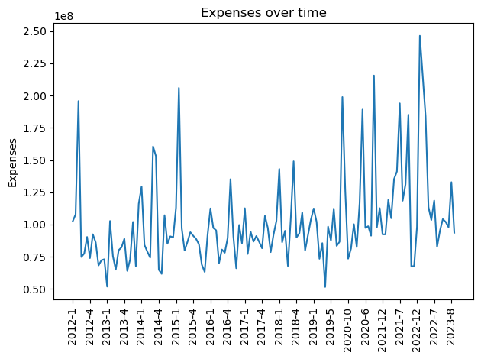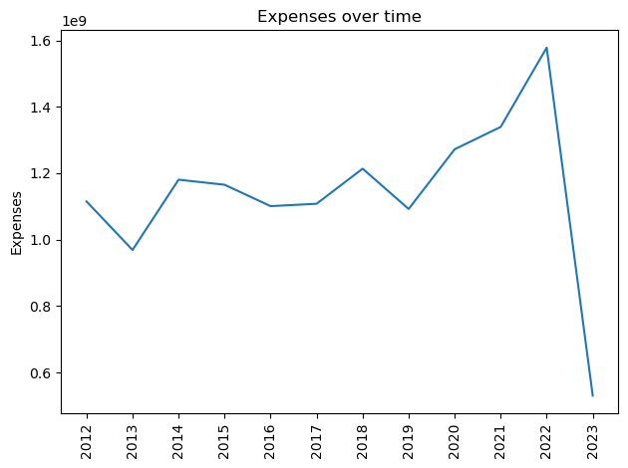

(a) (b)

.

(c)

Figure 7. Time series plot of the budget of the City of Boston. a) expenses by months. b) expenses by year. c) expenses by year, from base analysis

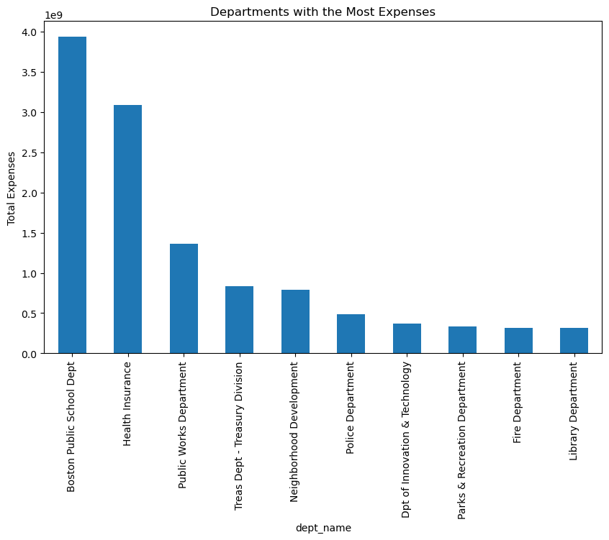

Figure 8. Histogram of spending of Deparments with the Most Expenses

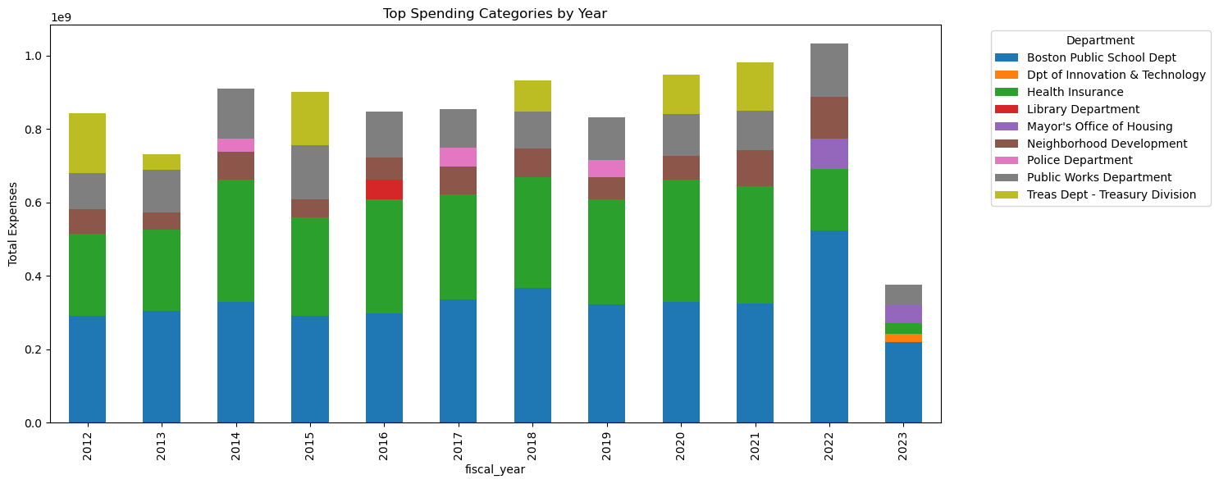

(a)

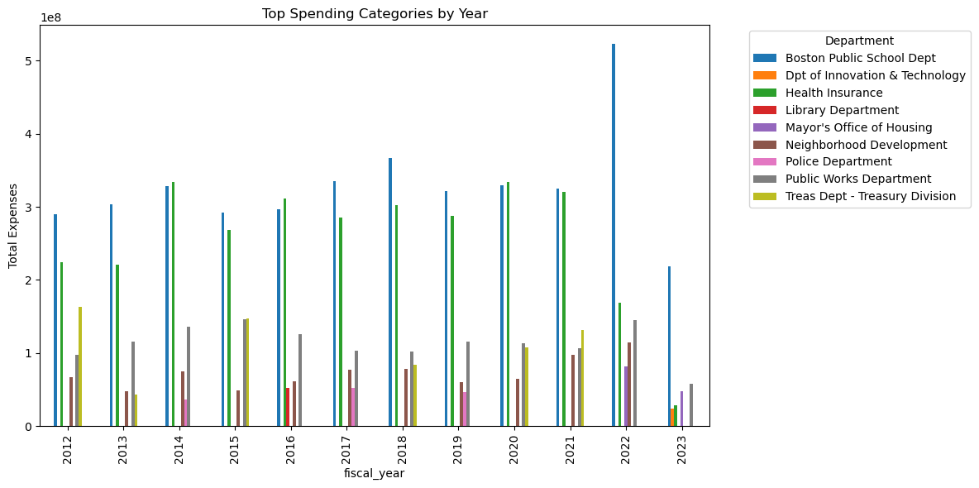

(b)

Figure 9. Top 5 Spending Departments of each Year, represented using stacked Histogram (a) and normal Histogram (b)

Over the years, the top 2 spending categories have been Boston Public Schools and Health Insurance (Fig 9), in which these two departments have very similar expenses from 2014 to 2021. However, in 2022, it seems that the spending for Boston Public Schools has skyrocketed by about 50%, while the spending for Health Insurance has decreased by about 50%, and seems to continue to decrease more in FY23 (previous results of FY21 to FY24 show that Health Insurance is continuing its decreasing trend). This perhaps is showing a change in emphasis from the city of Boston in distributing the majority of the budget.

The departments that have slightly less budget, such as Treasury, Public Works and Neighborhood Development, continue to have similar budget across the past decade. In 2021 and 2022, it seems like Public Works and Neighborhood Development is receiving more funds than before, especially Neighborhood Development, which shows continuous growth since 2012. These findings would again suggest that the city is shifting its focus, to possibly projects that has more social benefits.

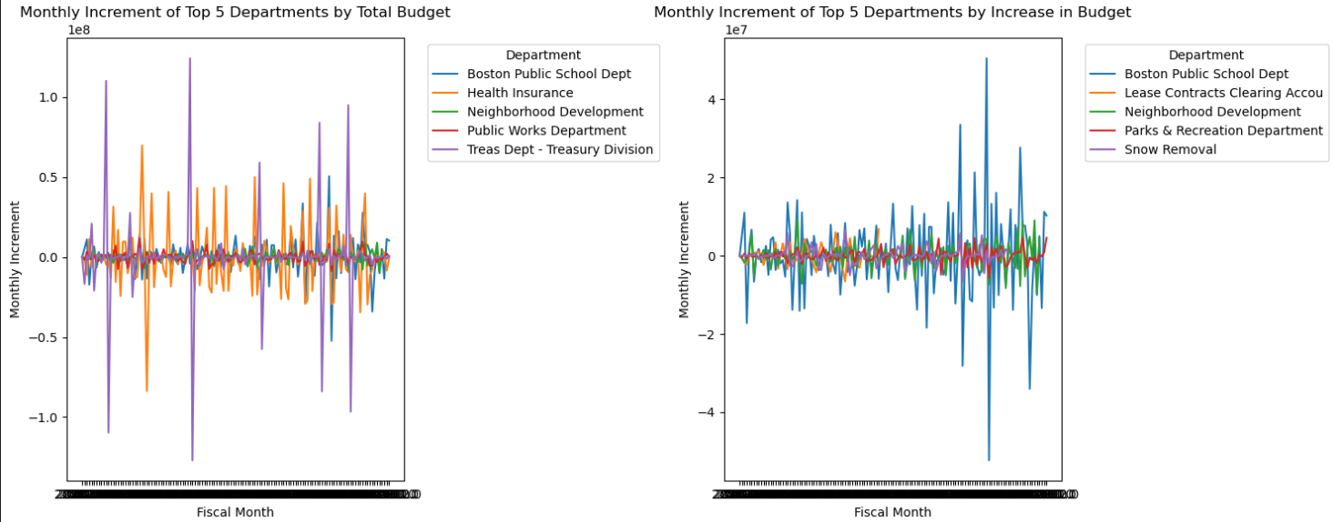

(a) (b)

Figure 10. Monthly Increments of the Top 5 Most Spending Departments (a) and Most Increased Budget (b)

In terms of the increments each month, the top 5 departments in increment and in total budget are compared (Fig 10). It shows that some large departments, such as Treasury Department, Health Insurance, and Public schools, have large change in budget over the months in a year, indicating that budgeting for these departments might be different from the budgeting for other ordinary departments. The percentage increment plots below show a similar fluctuation to these departments as well (Fig 11). One outstanding department is snow removal, which seems to be increasing drastically percentage wise in 2022, which could be a reason that winter budget is often higher.

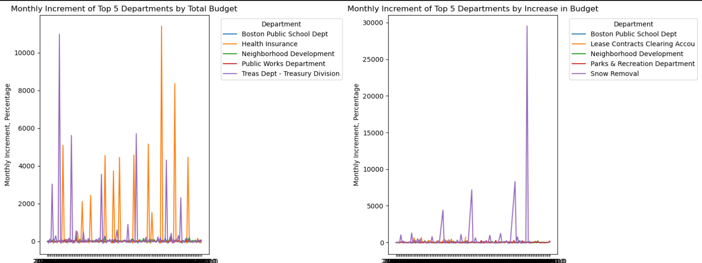

(a) (b)

Figure 11. Monthly Increments Percentages of the Top 5 Most Spending Departments (a) and Most Increased Budget (b)

For the bottom 5 departments in increments and in total budget (Fig 12), which are plotted below, we can see that the Treasury department, although being a department with the highest budget, is decreasing its budget significantly, similarly for the Health Insurance department. Snow and Winter management, which shows some decline, seems to be related to the month in the year as well (right), similar to Snow Removal.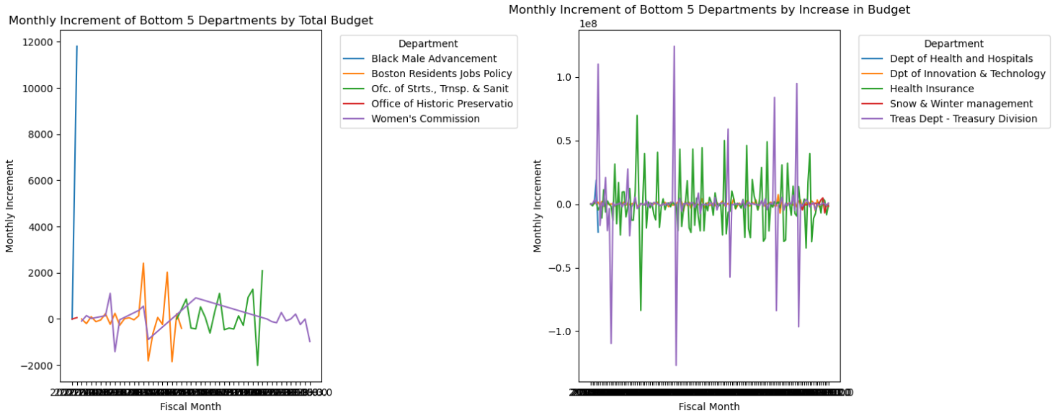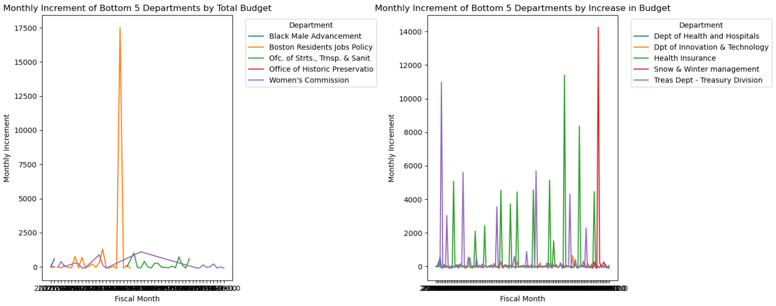

(a) (b)

Figure 12. Monthly Increments of the Bottom 5 Most Spending Departments (a) and Most Increased Budget (b)

On the other hand, for the yearly increments, the general pattern is similar to the monthly increments (Fig 12). As we can see from the plot below, being one of the department with the highest budget, the treasury department still fluctuate a lot. The same is true for the Health Insurance department as well, in which both of these departments show drastic decrease in 2022. Boston Public School Department, however, is the department that shows the strongest increase in recent years, especially in 2022. Its worth to note that the Public Works department is steady and increasing, which is a good sign for the direction that the city is taking.

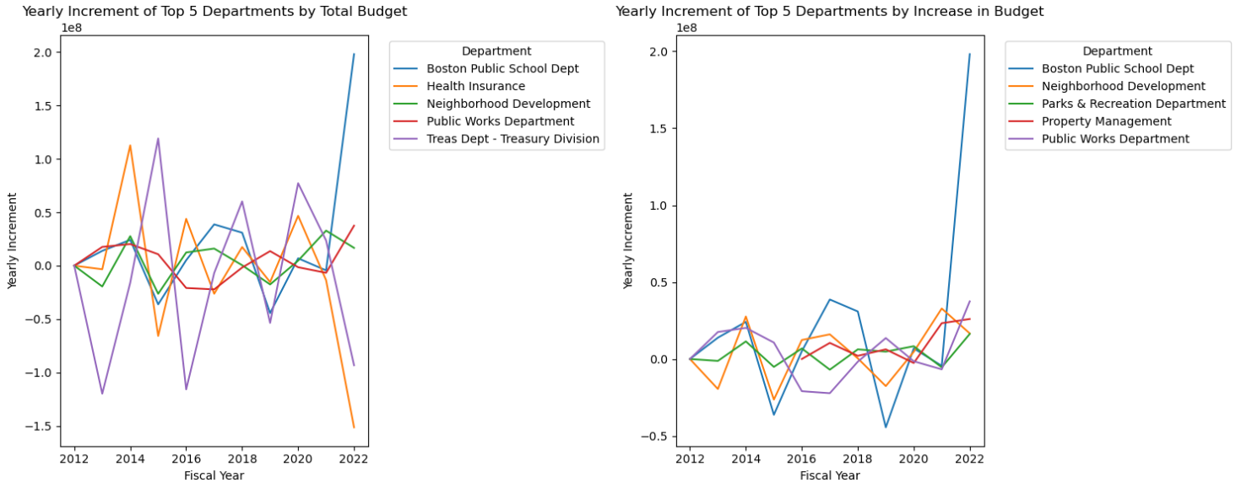

(a) (b)

Figure 12. Yearly Increments of the Top 5 Most Spending Departments (a) and Most Increased Budget (b)

When we put this increments in percentage as plotted below (Fig 13), some clear outliers are shown. Particularly, the Treasury Department shows unprecedent change in budget over the yeats, seems as if they budget every other year instead. Property Management department, which is a new department since 2016, shows immaculate growth in budget over some other department, such as the Public School Department, which we see a huge growth. This perhaps reflects the increasing need of the citizens to manage their asset in the city.

On the decreasing side, we once again see the great decline of the Treasury Department, as well as Health Insurance (Fig 14). Once again, these changes are showing the changes in the strategy of Boston’s budgeting. When the changes are put in percentage, we can see that Health Insurance and Leading the Way both show consistent decline over the years, in which Leading the Way as a department is discontinued in 2022. This result may signify the eventual outcome of Health Insurance as well, being replaced by or added to other department, since it is beginning losing its importance in the city budget.

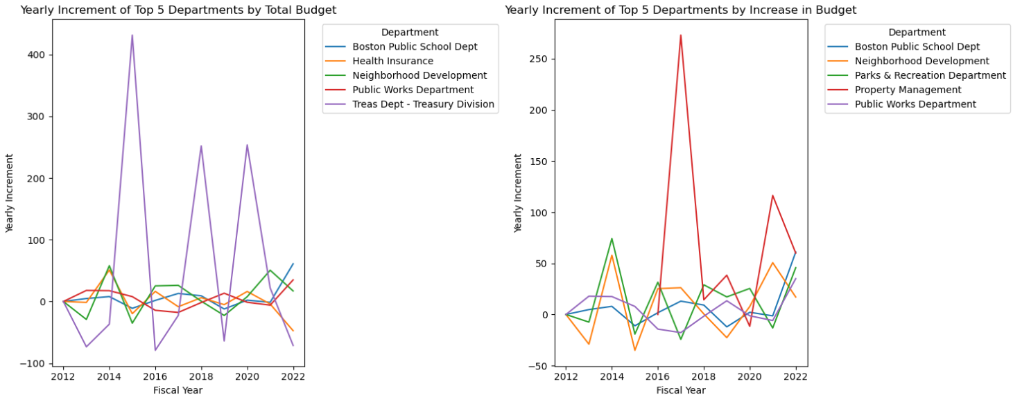

(a) (b)

Figure 13. Yearly Increments Percentages of the Top 5 Most Spending Departments (a) and Most Increased Budget (b)

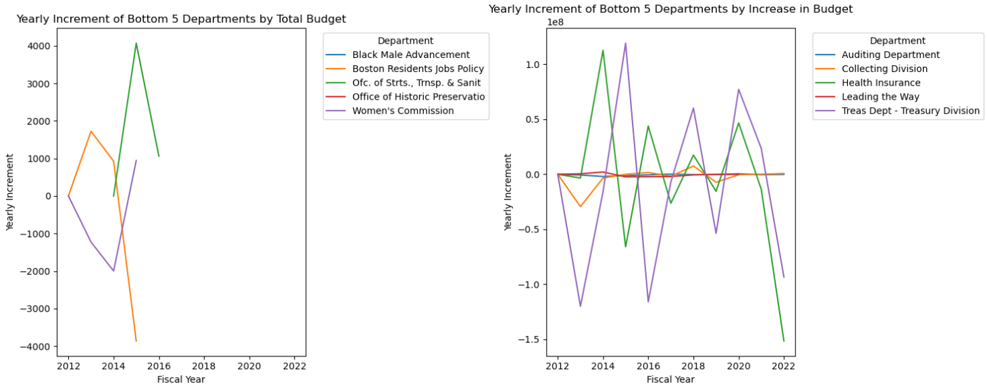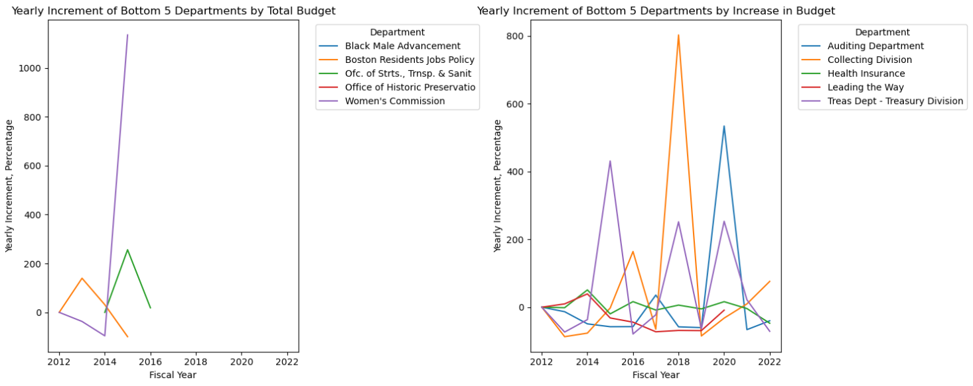

(a) (b)

Figure 14. Yearly Increments of the 5 Most Decreased Departments (left) and Yearly Increments percentages of the Bottom 5 Most Decreased Departments (right)

As for city revenues, there is a relatively limited amount of historical data available, but enough to make some inferences. As we can see here, over the years between 2002 and 2024 Boston’s tax revenue has become increasingly reliant on property taxes (Fig 15), the primary source of income for most municipalities. This could potentially be associated with the significant increase in property values within the same timeframe. As we can see here using data from the St. Louis Federal Reserve, Boston’s housing price index has more than doubled from 2002 to 2023. However, we can see that while property tax has increased from 52% of revenues to 72%, Boston’s commercial property tax rate has actually decreased, while the residential tax has remained about the same as it was in 2002, although it has decreased from highs in the early 2010s.

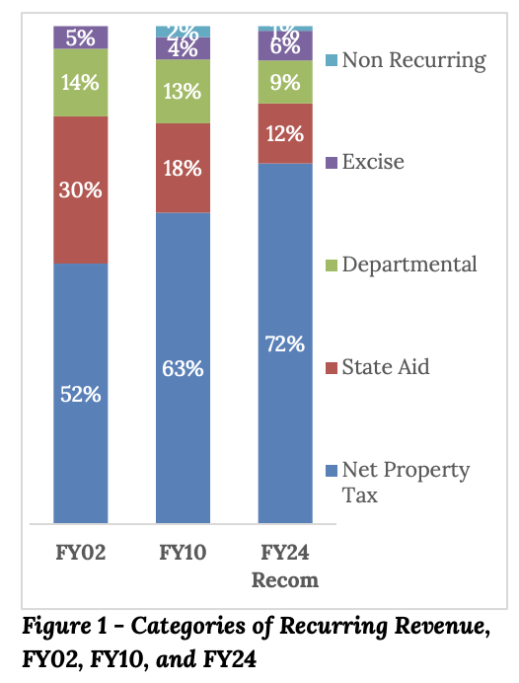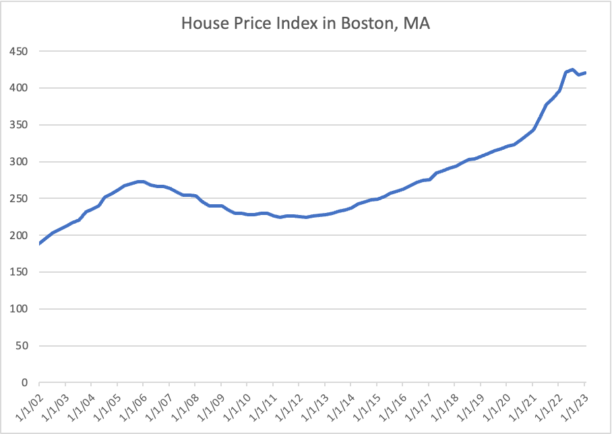

(a) (b)

Figure 15. Histogram of city revenue from different years (a), housing index plot (b) and Boston property tax rate (c)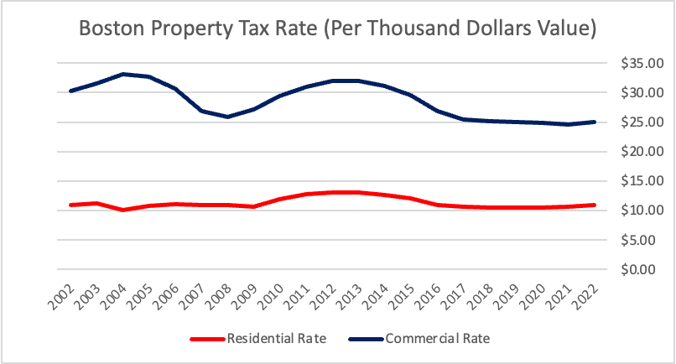

(c)

# 

# Conclusion

From our analysis on the base project, we can see that across different departments, categories, areas, and programs, budget of the city of Boston depends on various factors, where the most significant factor would be its correlation in time. From this temporal relationships, we can discern how the policies in the city has been shifted and where the emphasis is placed in the city. For example, we can see a very strong emphasis shift towards Boston Public Schools compared to other departments in the recent years, perhaps showing its increasing emphasis towards education in the city. On the other hand, in most areas, particularly near downtown, we can see how the budget is projected to spend in the future, possibly showing its plan for future development as well.

The extension project shows this temporal effect even further, in which the budget of different departments is continuously changing over time, some each year, and often by month as well. For example, we can see the general decreasing budget for the Treasury and Health Insurance departments in the yearly time, and their unpredictable fluctuation in different months. Overall, we can see how budget has changed in a temporal sequence across different departments.

# Challenges & Limitations

The biggest challenge is on the data, in which for the base project, the amount of data to consider is not very large, even with the additional data from the extension project, the overall length of the dataset only covers for slightly longer than a decade, which is not very efficient if we would like to analyze the behavior of the city budget over time. Having access to data that covers a much longer period of time, like 30 years, could bring us more insights in how the budgeting behavior has changed over time, and what the big direction is for the city budget. With this, we would also be able to combine it with contemporary events, such as COVID, or other factors, and consider the effect of such events on the city budget. Simultaneous, we would be able to develop machine learning models to extract the effect of different factors on the city budget as well. Therefore, being able to access more related datasets would provide us more directions to analyze more potential insights.

# Contributions

Wanchen Hong: Completed data cleaning and EDA, the spending by area sections and its related questions, including all visualizations and analysis, and the extension project. Rewrote and formatted the entire report

Alex Zhang: Completed work on spending by category (Visualizations, analysis and questions)

Zhupei Xu: Completed work on spending by department

Phil Ledoit: Completed work on spending by program (visualizations, analysis and questions)